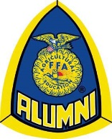
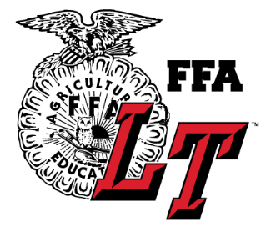
Lake Travis FFA
Alumni Association

Meeting Agenda 10/2/17

- Introduction
- Approve minutes from last meeting
- Teacher Update- Perry White
- Budget- Camille Ballou

- Membership- turn in forms and money to Camille

- Fundraising:
- Sponsor Acknowledgement and Thank you!
- Southern Soiree- October 13
- Buy your tickets today
- Side -O- Beef Tickets –Pick them up tonight
- Pet Shot Clinic November 12
-Sponsorship Drive: Deadline Nov 17

- TCYS Project Entry Forms Due Oct 12
Turn in Form and Money to one of the Ag teachers
http://www.traviscountyyouthshow.org

- Calendar- subject to change
-LT homecoming parade, Oct. 3
-Lamb and Goat Jackpot Shows Oct. 6,7,13 and 27th
-TCYS Project Entry forms due Oct. 12
-LT FFA Southern Soiree Oct. 13
-Lamb and Goat validation Oct 16 4pm
-Ronnie Smith Memorial Buyers Group Fundraiser Oct. 26
-LT FFA Lamb and Goat Show Nov. 3
-Swine validation Nov. 11
-Pet Shot Clinic Nov 12 5pm
www.laketravisffa.ffanow.org

